ALLOT BSA

USER MANUAL

JAN-2026

©ALLOT
All rights reserved


ALLOT

Business Solution & Automation

To simplify and accelerate industrial operations through intelligent automation — empowering businesses to scale faster, operate smarter, and stay audit-ready.

Our new SaaS platform is built with one clear mission: to simplify industry automation. From procurement to warehouse management, from approvals to inventory control — everything is now unified in one intelligent system.

“let’s make industry automation easy, scalable, and future-ready.”
With this solution, industries can expect faster approval cycles, improved inventory accuracy, and seamless audit preparation. It’s not just software — it’s a transformation engine for modern enterprises.

We invite businesses, partners, and innovators to join us in this journey.

-Al Amin
Industries Expert

Index

Item Details

Item UOM
Through this feature, you can predefine the measurements for your items or products. These predefined units will be required later when adding new items or products to the system. Below are some examples of Units of Measurement (UOM):
Ex: Packet, Roll, Piece, Kilogram

Item Group
Through this feature, you can predefine the group for your items or products. These predefined groups will be required later when adding new items or products to the system. Below are some examples of groups of items/products-
Ex: Maintenance Item, IT Item, Admin Item

Item Type
Through this feature, you can predefine the type for your items or products. These predefined types will be required later when adding new items or products to the system. Below are some examples of types of items/products-
Ex: Stationary Items, Spare Parts, Consumables

Cost Center
Through this feature, you can predefine the department/section for your organization. These predefined cost centers will be required later when adding a new member/user to the system. Below are some examples of department/cost center -
Ex: Admin, Finance, Sales

Warehouse Location
This feature allows you to predefine storage locations for your warehouse or inventory. These predefined locations will be essential when recording product receipts in the system. Below are some examples of warehouse locations -
Ex: ST01:C01C:B10, ST02:C01C:B10, ST03:A01C:B01

Add Item Details
Step 01: Item Master >> Item Details >> Add Details
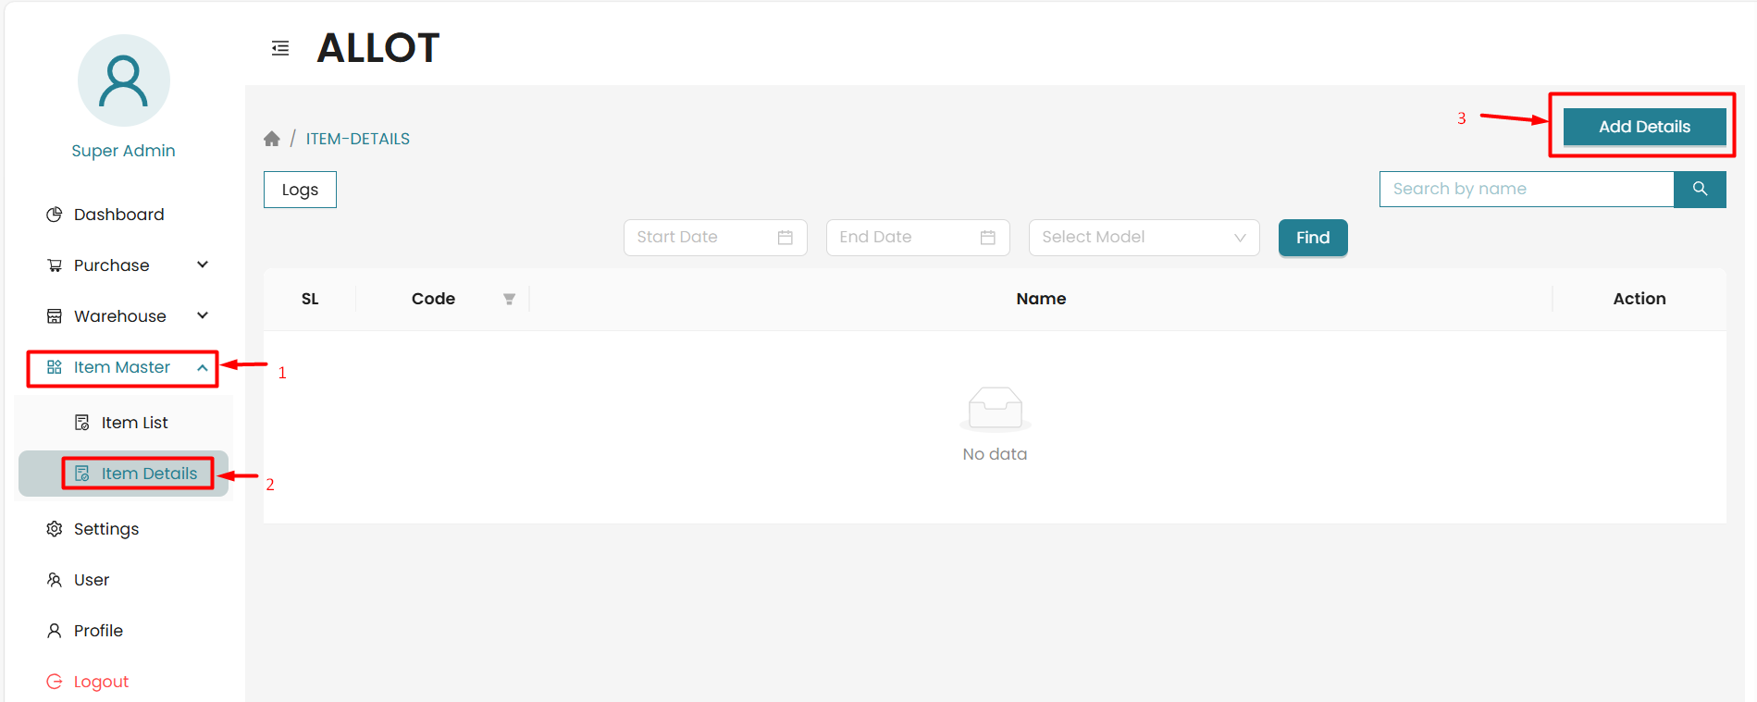

Step 01: Select the model from the drop-down and give the details name as per the selection
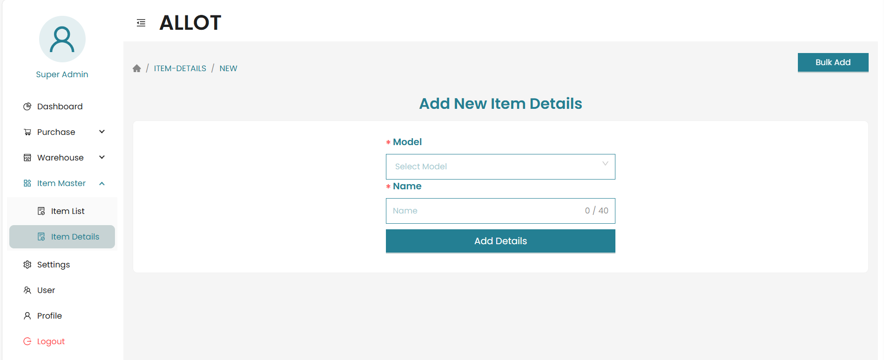
Code required for UOM only, code limit will be 4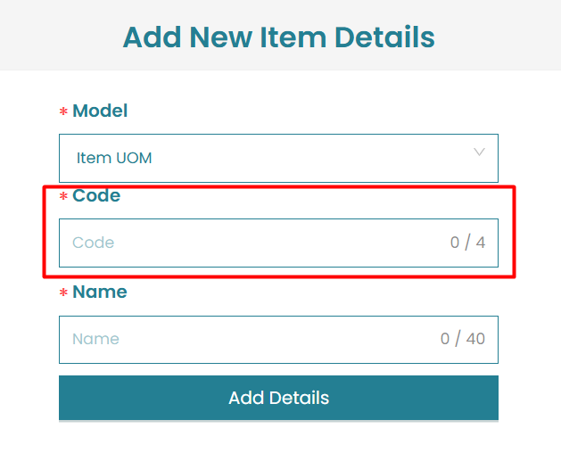
Consideration:
- Each name must be unique within the system.
Validates:
- Duplicate names cannot be added.
- If the name already exists in the database, the system will display a pop‑up notification.
- A confirmation message will be displayed when a new record is successfully added.

View Item Details
Step 01: Item Master >> Item Details >> set start and end date with details type
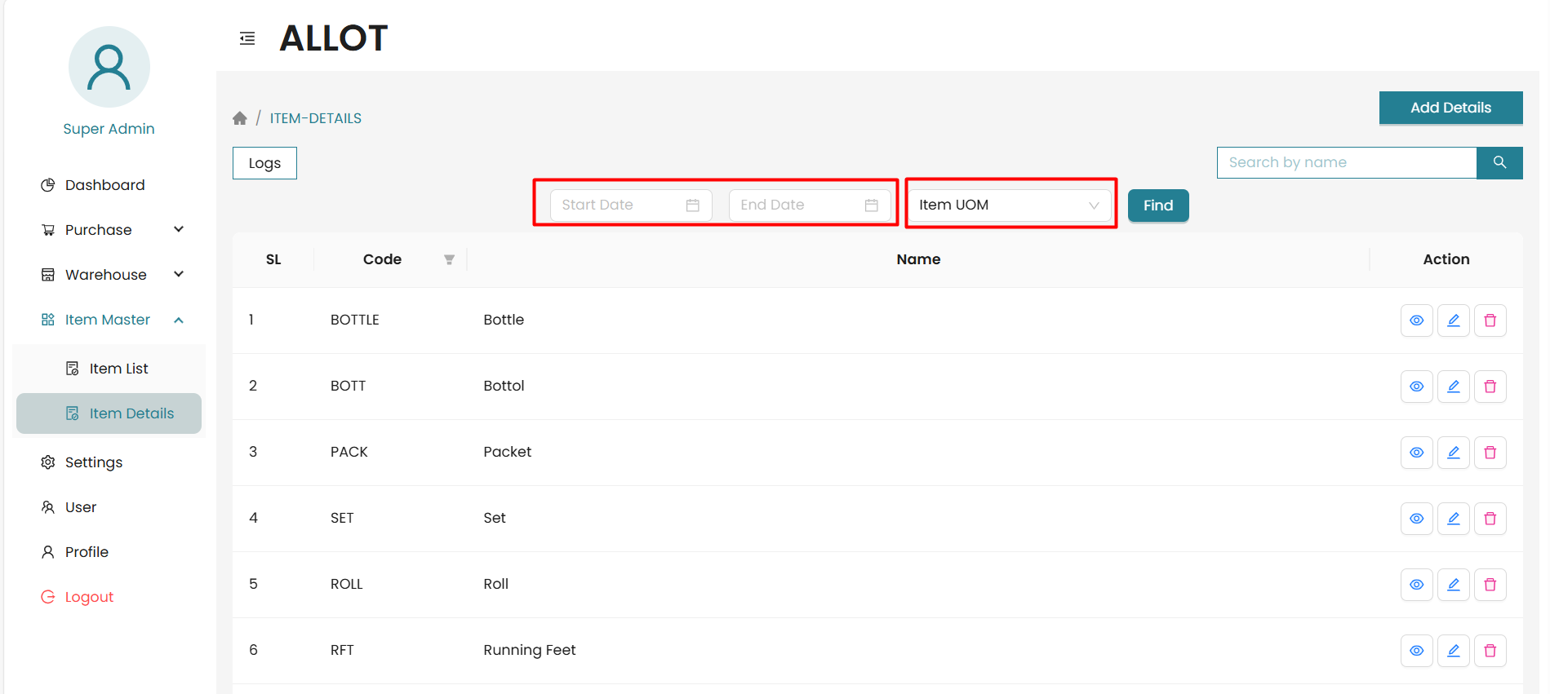
Consideration:
- Each name must be unique within the system.
Validates:
- Duplicate names cannot be added.
- If the name already exists in the database, the system will display a pop‑up notification.
- A confirmation message will be displayed when a new record is successfully added.

Edit Item Details
Step 01: Item Master >> Item Details >> Details Table >> Edit
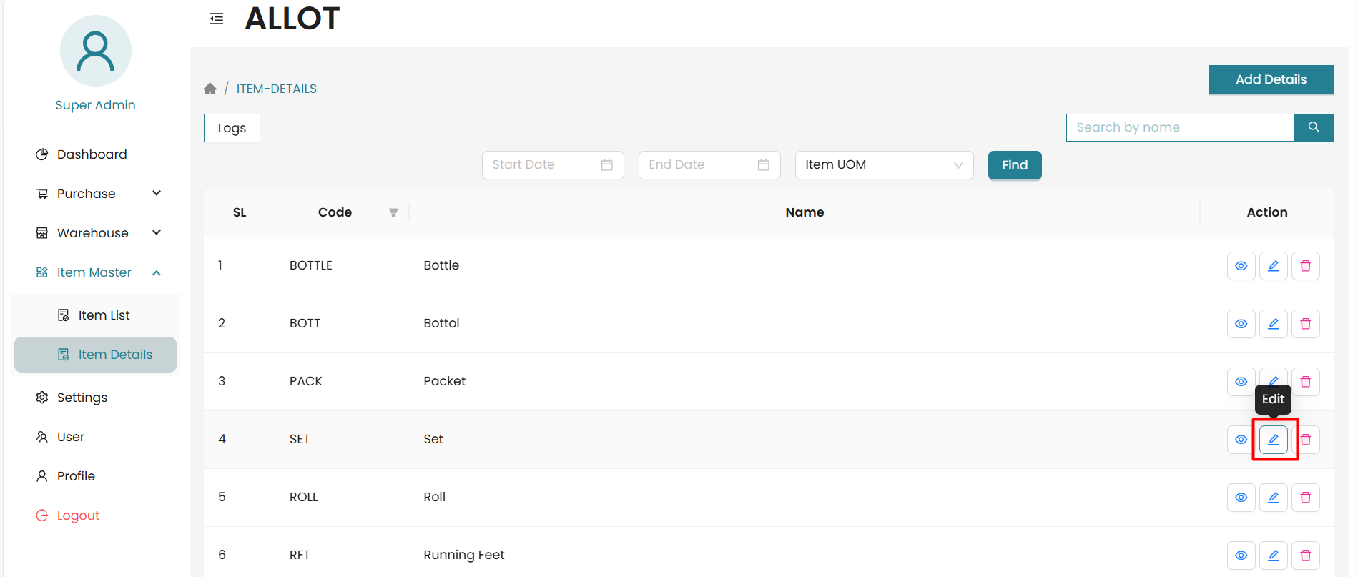
Step 02: Edit Required Information >> Update Details
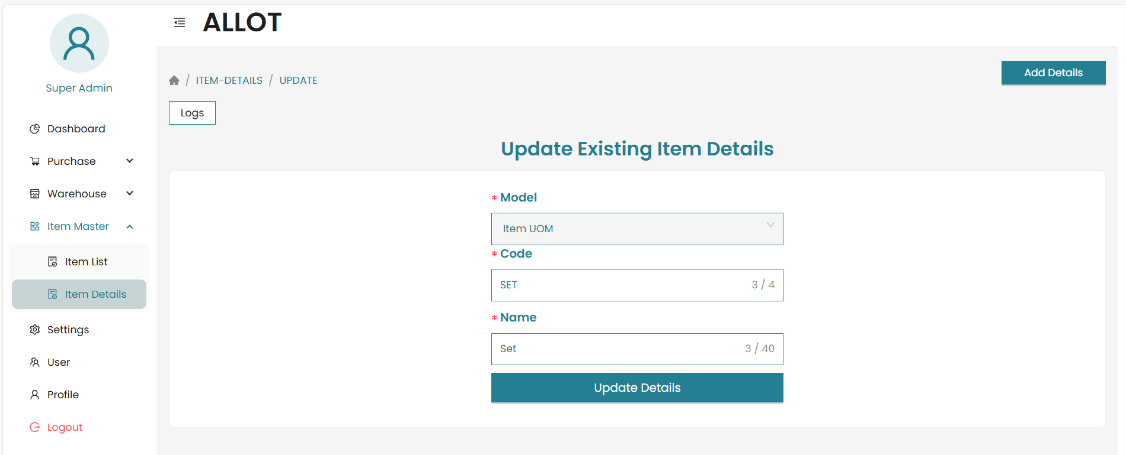

Delete Item Details
Step 01: Item Master >> Item Details >> Details Table >> Delete
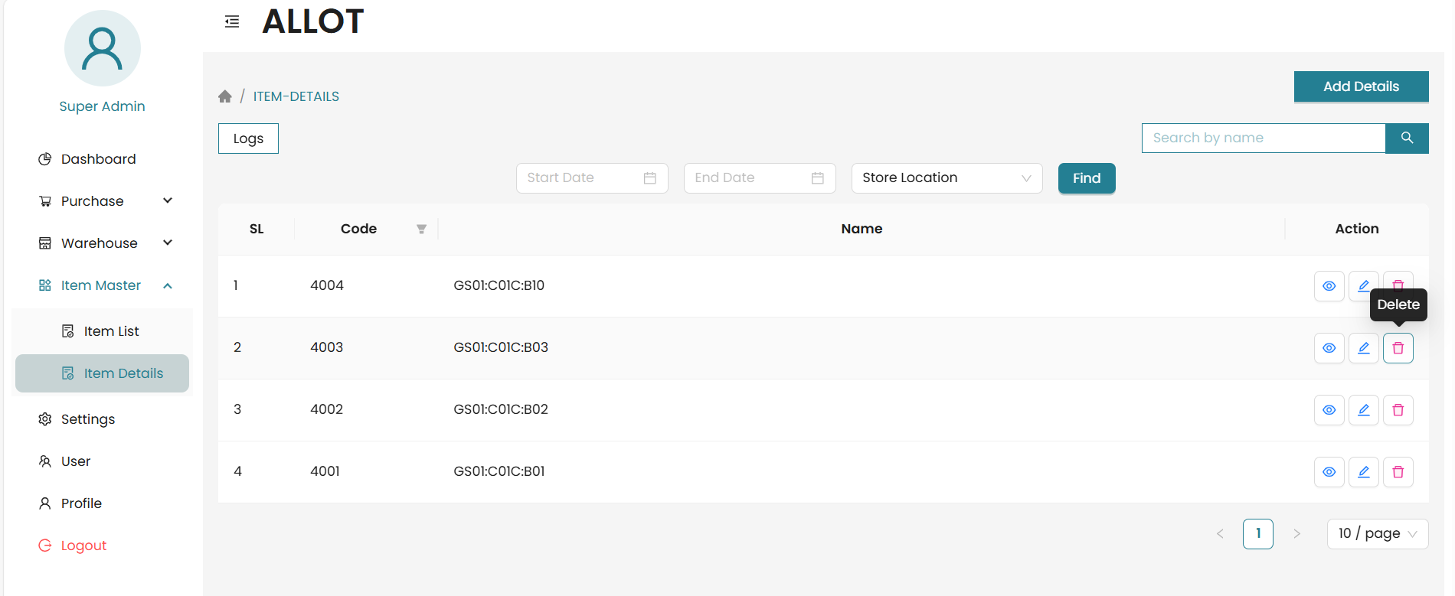

Item/Product

Add Item

Edit Item

Delete Item

